|  |  |
| --- | --- |
| **Ex. No. 8** | **Web Application Development using Angular JS Framework** |
| **Date of Exercise** | 04-11-2022 |
| **Web Host Link** | <https://ysriganesh.github.io/webapp/web%20tech/first.html>  <https://ysriganesh.github.io/webapp/web%20tech/secound.html> |
| **Youtube Link** |  |

**Aim**

To develop website using HTML, CSS and Angular JS client side Model View Controller

Framework.

**Description**

To develop website using HTML, CSS and Angular JS client side Model View Controller

Framework. AngularJS is an open source JavaScript framework developed and maintained by Google.

It implements the MVC (Model View Controller) pattern to separate data, presentation and logical

components.

Description

AngularJS Architecture

AngularJS is a Single Page Application (SPA) meta-framework. Angular JS follows the MVC

architecture. MVC stands for Model-View-Controller evolved as a way to separate data, logical units

and presentation in web application development.

• The model is the driving force of the application. This is generally the data behind the

application, usually fetched from the server.

• The view is the UI that the user sees and interacts with. It is dynamic, and generated based on

the current model of the application.

• The controller is the business logic and presentation layer, which performs actions such as

fetching data and makes decisions such as how to present the model, which parts of it to display,

etc.

AngularJS Extends HTML

• AngularJS extends HTML with ng-directives.

• The ng-app

o directive defines an AngularJS application

• The ng-init

o directive used to create initial value(model) for the angular JS application.

• The ng-model

o directive binds the value of HTML controls (input, select, textarea) to application

data.

• The ng-bind

o directive binds application data to the HTML view

**Program**

First question :

<!DOCTYPE html>

<html lang="en">

<head>

    <script src="https://ajax.googleapis.com/ajax/libs/angularjs/1.6.9/angular.min.js"></script>

    <style>

        *{

            margin: 0px;

            padding: 0px;

        }

    </style>

    <script>

        var app=angular.module("myApp",[])

        app.controller('control',function($scope)

        {

            $scope.process = function()

            {

                var w=parseInt($scope.data1)

                var h=parseInt($scope.data2)*0.01

                $scope.result= Math.round((w/(h**2)))

                if($scope.result<18)

                {

                    $scope.catagory='Underweight'+' BMI'

                }

                else if ($scope.result>18 && $scope.result<25)

                {

                    $scope.catagory='Normal weight'+' BMI'

                }

                else if ($scope.result>25 && $scope<30)

                {

                    $scope.catagory='Overweight'+' BMI'

                }

                else if ($scope.result>30)

                {

                    $scope.catagory='Obese'

                }

                else

                {

                    $scope.catagory=' '

                }

            }

        })

    </script>

</head>

<body ng-app="myApp" ng-controller="control">

        <div style="background-color: rgb(23, 203, 223); width: 100%; height: 79.5px;">

            <h1 style="color: white;padding-left: 10px;">Body Mass Index</h1>

            <p style="color: white; padding-left: 11px;font-size: 18px;" >A measure of body fat in adults</p>

        </div>

        <div style="padding-left: 10px; padding-top: 7px;">

        <p >Weight :</p><input type="text" ng-model="data1" ng-keyup="process()" style="height:28px;border: 1.6px solid black; width: 200px;"> kg<br>

        <p >Height :</p><input type="text" ng-model="data2" ng-keyup="process()" style="height:28px;border: 1.6px solid black;width: 200px; "> cm<br><br></div>

        <div ng-bind="result" style="position: absolute; color: rgb(3, 92, 98);text-align: center ;width: 100px;font-size: 50px; height: 90px; left: 500px; top: 120px; "></div>

        <div ng-bind="catagory" style="position: absolute;  width: 200px;text-align: center; height: 20px; left: 460px; top:170px; "></div>

</body>

</html>

Secound Question:

<!DOCTYPE html>

<html lang="en">

<head>

    <meta charset="UTF-8">

    <meta http-equiv="X-UA-Compatible" content="IE=edge">

    <meta name="viewport" content="width=device-width, initial-scale=1.0">

    <meta charset="UTF-8" />

    <meta http-equiv="X-UA-Compatible" content="IE=edge" />

    <meta name="viewport" content="width=device-width, initial-scale=1.0" />

    <script src="https://ajax.googleapis.com/ajax/libs/angularjs/1.6.9/angular.min.js"></script>

    <link href="https://cdn.jsdelivr.net/npm/bootstrap@5.2.1/dist/css/bootstrap.min.css" rel="stylesheet" />

    <script src="https://cdn.jsdelivr.net/npm/bootstrap@5.2.1/dist/js/bootstrap.bundle.min.js"></script>

    <title>Array Operation</title>

</head>

<body ng-app="myApp" ng-controller="myCtrl">

    <script>

        var app = angular.module("myApp", []);

        app.controller("myCtrl", function ($scope) {

            $scope.items = [];

            $scope.addItems = function(){

                $scope.items.push({productName: $scope.name, price: $scope.price});

            }

            $scope.removeItems = function($index){

                $scope.items.splice($index,1);

            }

        });

    </script>

    <form  class="p-5">

        <center>

            <h2 class="text-primary">Product Inventory System </h2>

        </center>

        <div class="mb-3 mt-3">

            <label for="name" class="form-label text-primary ">Enter the Product Name:</label>

            <input type="text" class="form-control border-dark text-danger" id="name" name="name" ng-model="name"/>

        </div>

        <div class="mb-3">

            <label for="empID" class="form-label text-primary">Enter the Product Price:</label>

            <input type="text" class="form-control border-dark text-danger" id="empID" name="price" ng-model="price"/>

        </div>

        <center><button ng-click="addItems()" type="submit">Add Product</button></center>

    </form>

    <center class="p-5">

        <table class="table table-striped" border="1" cellspacing="0" width="50%" style="text-align:center;">

        <thead class="bg-success text-light">

            <tr >

                <th>Name</th>

                <th>Price</th>

                <th>Remove</th>

            </tr>

        </thead>

        <tbody>

            <tr ng-repeat="x in items">

                <td style="color: blue;">{{x.productName}}</td>

                <td style="color: blue;">{{"Rs."+x.price}}</td>

                <td>

                <button ng-click="removeItems($index)">Remove</button>

                </td>

            </tr>

        </tbody>

    </table></center>

</body>

</html>

**Output**

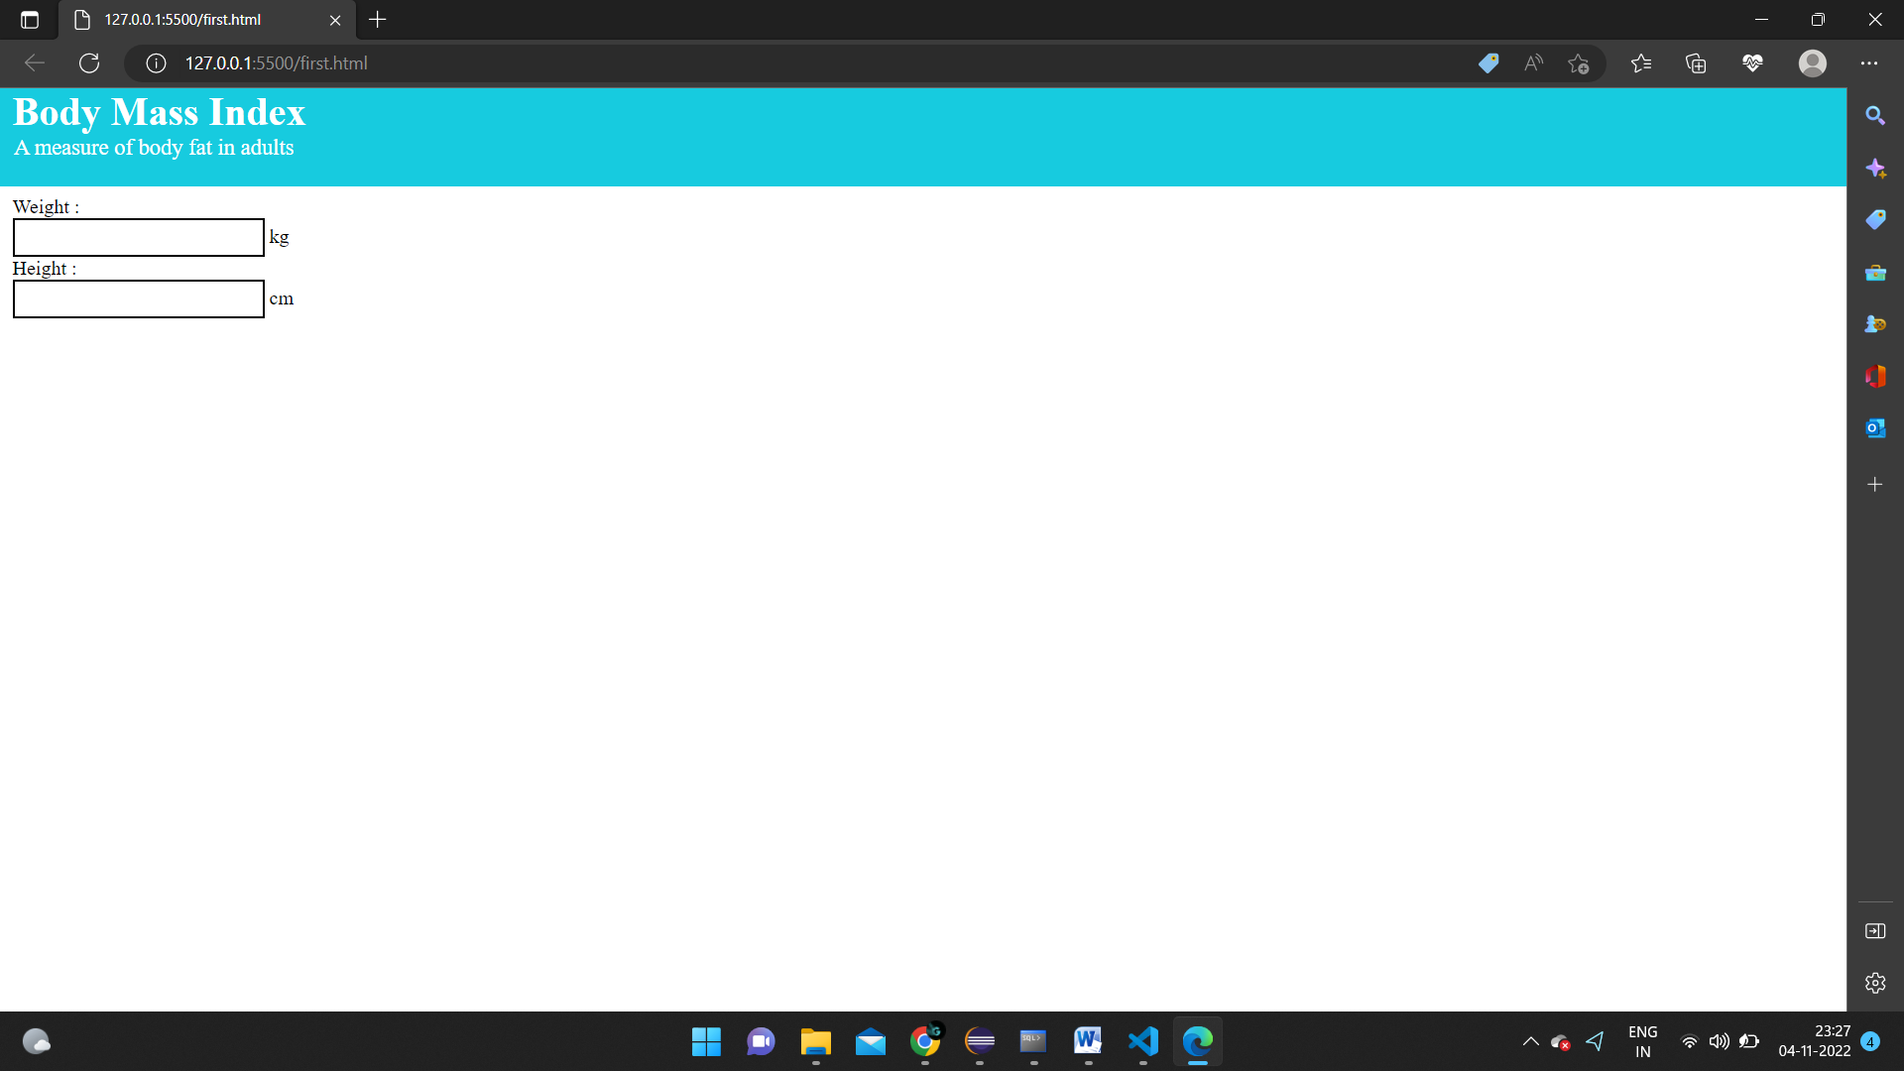

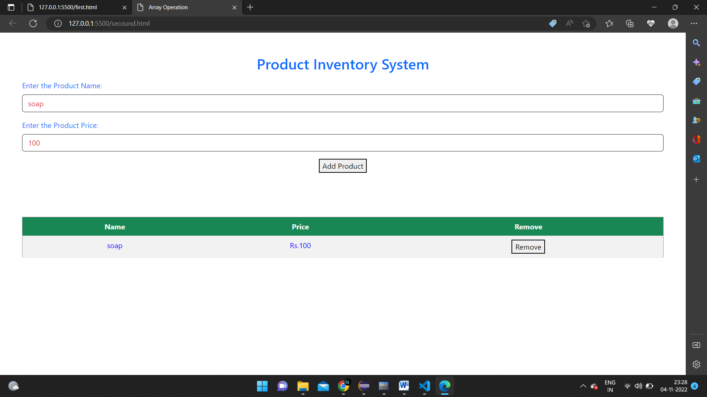

**Result**

Here we created website using html css and angular js and got the required output